Ex.No. 2: Implementing TDMA Slot Allocation in GSM.
AIM: To implement TDMA (Time Division Multiple Access) slot allocation in GSM using MATLAB and analyze system performance in terms of time slot duration, frame utilization, and number of allocated slots.
Objective:
- To calculate the Time Slot Duration in a GSM TDMA frame by dividing the total frame time into equal time slots. This helps in understanding the time structure of GSM communication.
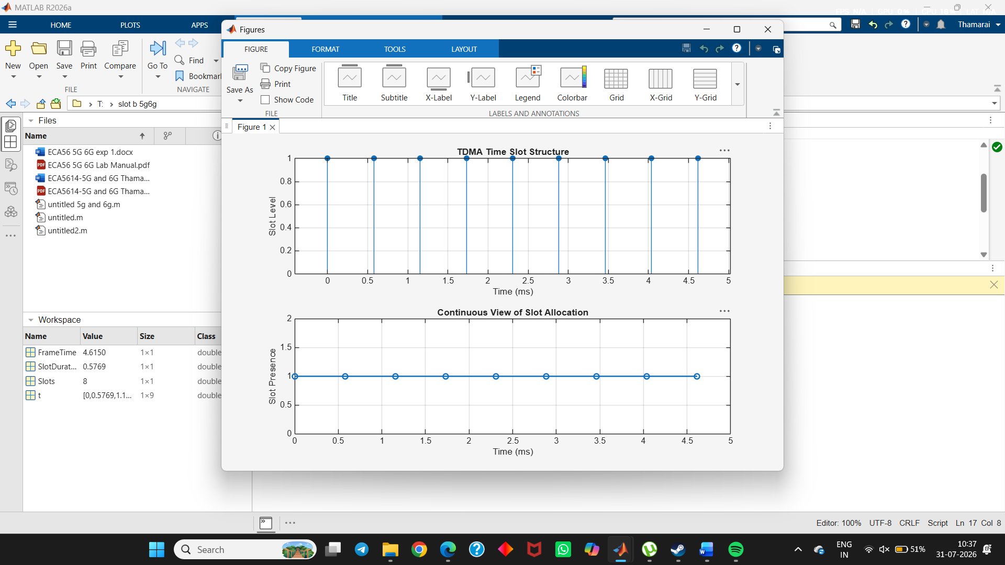
- To determine the Frame Utilization (%) based on the number of allocated time slots compared to total available slots. This evaluates the efficiency of TDMA resource usage.
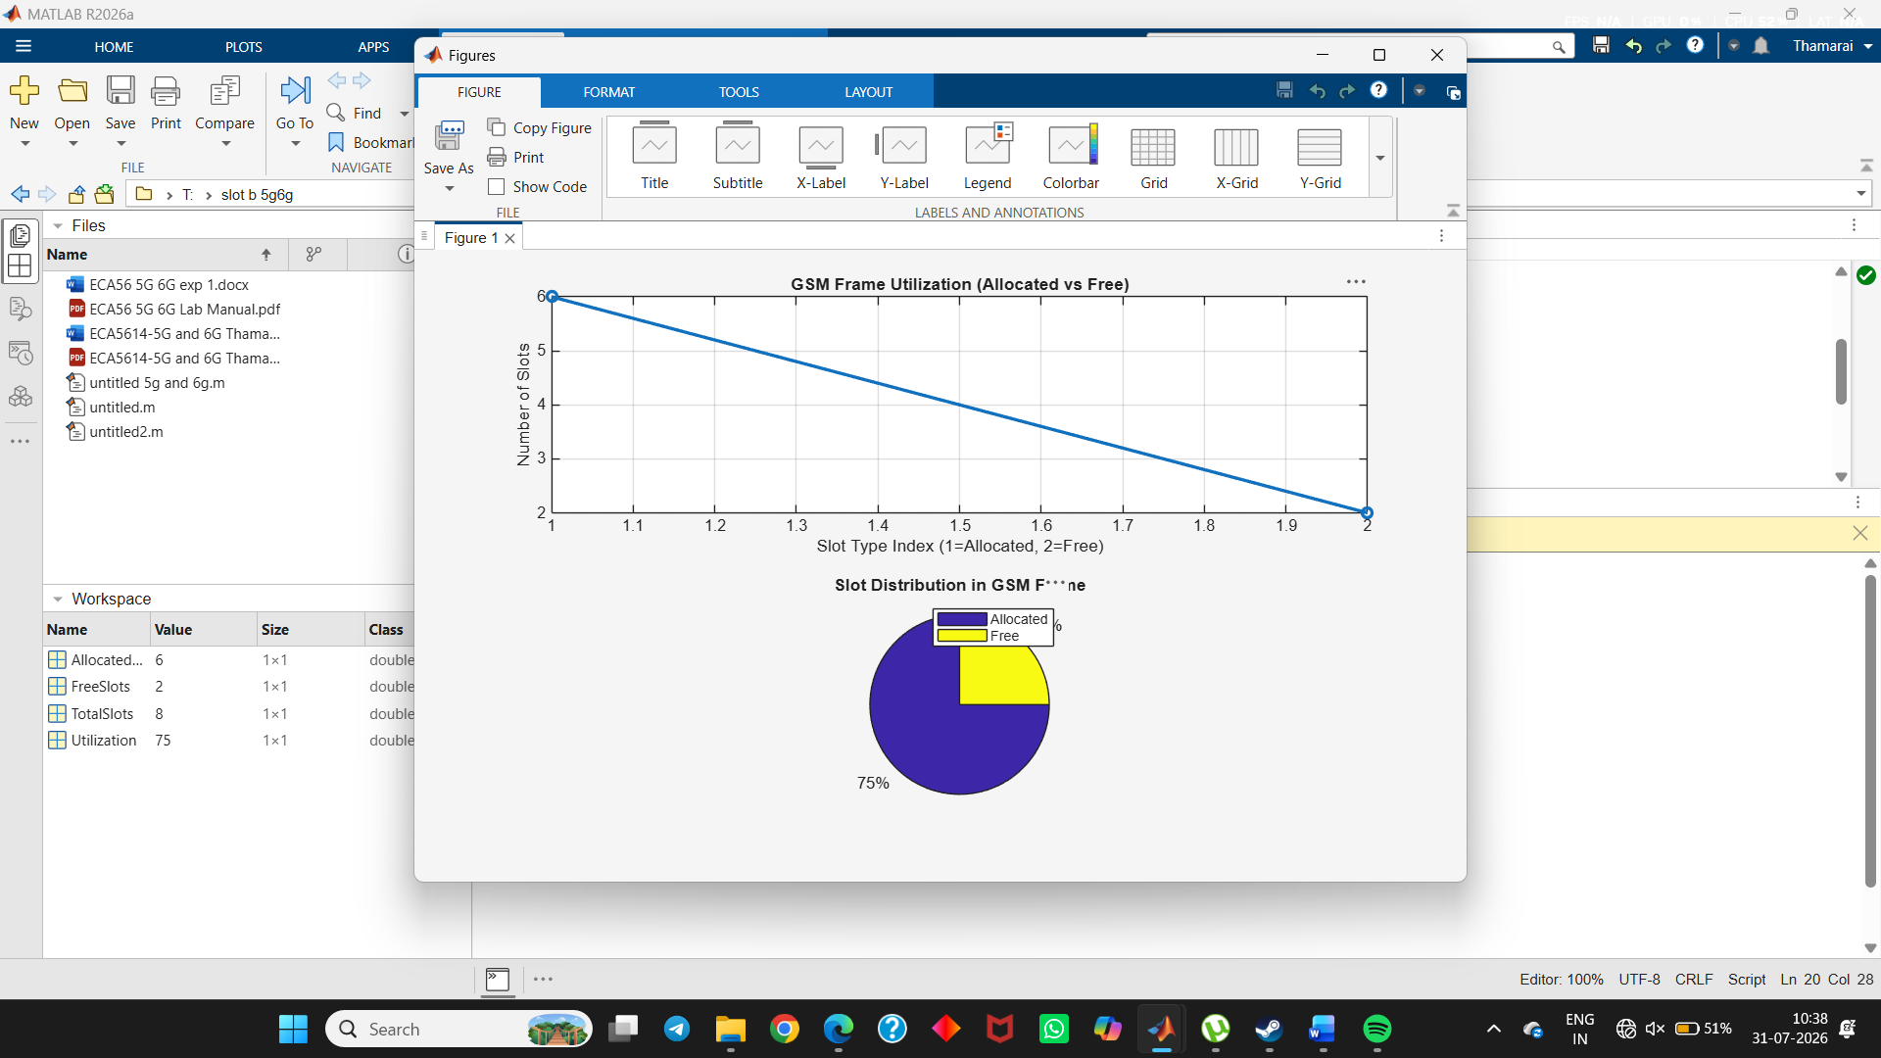
- To compute the Number of Allocated Time Slots for multiple users in the GSM system. This ensures proper scheduling and interference-free communication.
